BLIND SQL INJECTION
VULNERABILITY ASSESSMENT REPORT
Practical Security Assessment – DVWA Laboratory

Student | Daberechi Success
track | Networking and cyber security
Testing Environment | Local DVWA Docker Laboratory
Assessment Type | Controlled Web Application Security Testing
Date | [Insert submission date]

Table of Contents
- 1. Introduction
- 2. Objectives
- 3. Testing Environment
- 4. Identification of the Blind SQL Injection Point
- 5. Boolean-Based Blind SQL Injection Validation
- 6. Time-Based Blind SQL Injection Validation
- 7. Database Enumeration
- 8. Password Hash Analysis
- 9. Comparison of SQL Injection Techniques
- 10. Security Impact
- 11. Recommended Mitigations
- 12. Conclusion
- 13. Evidence Checklist

1. Introduction
This practical exercise was carried out in a controlled DVWA (Damn Vulnerable Web Application) environment to identify, validate, and analyze a Blind SQL Injection vulnerability. The exercise focused on an application that does not display database errors or query output directly. Boolean-based and time-based techniques were therefore used to determine whether user-supplied input was being processed by the underlying database.
The exercise also involved identifying the database structure, examining the users table and credential-related columns, and analyzing the likely password-hashing format. All testing was performed against the intentionally vulnerable local laboratory application.

2. Objectives
- Identify a SQL injection point operating in a blind environment.
- Confirm the vulnerability using Boolean-based SQL injection.
- Confirm the vulnerability using time-based SQL injection.
- Identify the database used by the application.
- Identify relevant database tables and columns.
- Investigate the storage of user credentials and password hashes.
- Determine the likely hashing algorithm used, while noting evidentiary limitations.
- Explain the differences between error-based, Boolean-based, and time-based SQL injection.

3. Testing Environment
Operating System | Ubuntu/WSL environment on Windows 11
Target Application | Damn Vulnerable Web Application (DVWA)
Deployment | Docker
DVWA Security Level | Low
Target URL | http://localhost:4280
Testing Method | Browser-based manual Boolean and time-based payload testing
Database | MySQL/MariaDB-compatible DVWA database

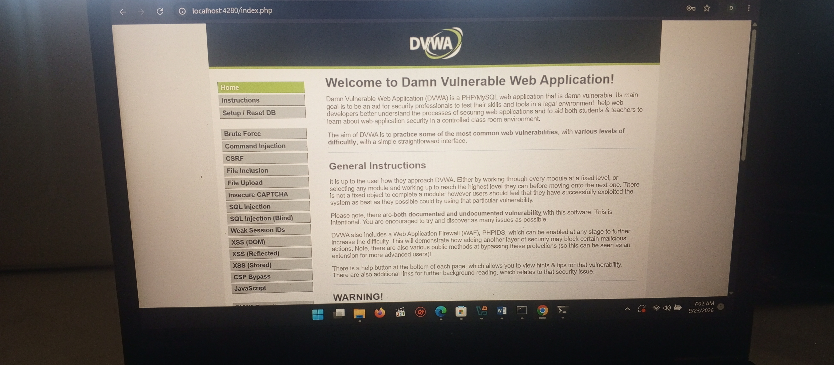

4. Identification of the Blind SQL Injection Point
The DVWA SQL Injection (Blind) module was selected for testing. Unlike an error-based injection point, this page did not display useful database error messages or the result of the SQL query. Instead, it returned a simple response indicating whether a supplied user ID was present or missing.
The difference between these two application responses provided an observable condition that could be used to infer how the database evaluated the input. This behavior made the page suitable for Boolean-based and time-based blind SQL injection validation.

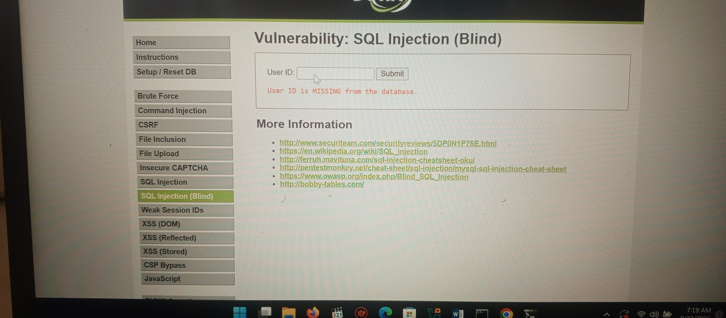

5. Boolean-Based Blind SQL Injection Validation
Boolean-based testing was performed by submitting conditions designed to evaluate as TRUE and FALSE. The application returned “User ID is present in the database” for the TRUE condition and “User ID is MISSING from the database” for the FALSE condition.
Because the application response changed according to the truth value of the injected condition, the test demonstrated that the input affected the database query. This response difference confirmed the presence of a Boolean-based Blind SQL Injection vulnerability in the controlled DVWA environment.
Observed result (not captured in a screenshot): submitting a TRUE condition (e.g. 1’ AND ‘1’=‘1) returned “User ID is present in the database,” confirming the true branch of the injected condition.
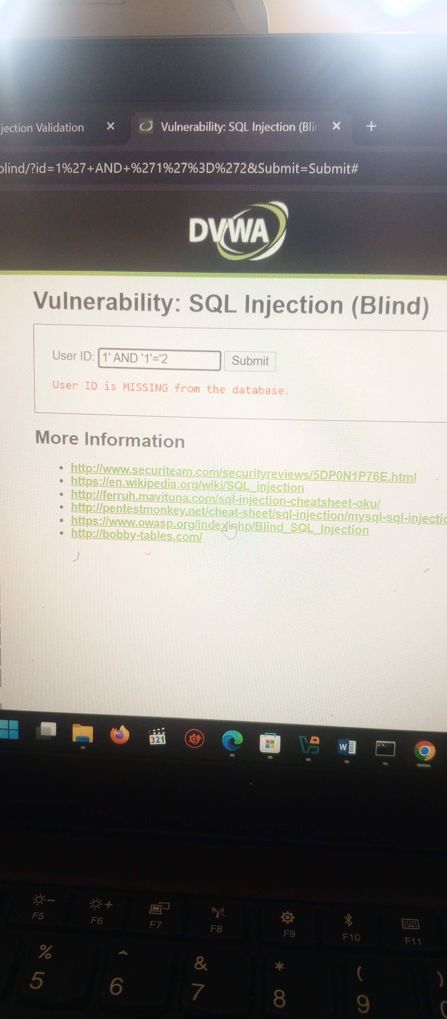

6. Time-Based Blind SQL Injection Validation
Time-based testing was used as a second validation method. A condition containing a five-second database delay function (SLEEP(5)) caused a noticeable delay in the response. A control test using SLEEP(0) returned normally.
The delayed response, despite the page displaying a missing-user message, showed that the database was processing the time-delay expression. Comparing the delayed test with the control test provided additional evidence of a time-based blind SQL injection condition.
Observed result (not captured in a screenshot): submitting a condition containing SLEEP(5) caused the page to take noticeably longer than five seconds to respond, before returning its normal missing-user message.
Observed result (not captured in a screenshot): the SLEEP(0) control test returned immediately, with no noticeable delay, confirming the delay above was caused by the injected SLEEP(5) expression rather than normal page load time.

7. Database Enumeration
After validating the injection point, Boolean conditions were used to infer selected database structure details. The database name “dvwa” was confirmed. Further tests indicated that a table named “users” existed and that it contained the “user” and “password” columns.
These results demonstrate that information about the database schema could be inferred without the application displaying the query output directly.
Item | Observed result
Database | dvwa
Table | users
Columns confirmed | user, password
Observed result (not captured in a screenshot): a boolean condition testing database()=‘dvwa’ returned “User ID is present in the database,” confirming the database name.
Observed result (not captured in a screenshot): a boolean condition testing for a table named ‘users’ in information_schema.tables returned “User ID is present in the database,” confirming the table’s existence.
Observed result (not captured in a screenshot): boolean conditions testing for ‘user’ and ‘password’ columns in information_schema.columns for the users table each returned “User ID is present in the database,” confirming both columns.

8. Password Hash Analysis
A length-based Boolean test indicated that a stored password value was 32 characters long. A 32-character hexadecimal digest is consistent with an MD5 hash, so MD5 is a possible format for the value stored in this DVWA setup.
This was subsequently confirmed using the standard (non-blind) SQL Injection module in the same DVWA instance, which permitted a UNION-based query (1' UNION SELECT user, password FROM users-- -) to return the user and password columns directly. The retrieved values were 32-character hexadecimal strings (for example, 5f4dcc3b5aa765d61d8327deb882cf99), which is the correct length and format for an MD5 digest. This corroborates, rather than replaces, the blind-injection length inference: the blind technique alone could not read the hash content, but the follow-up UNION-based test on the related module confirmed both the length and the hexadecimal MD5 format. No attempt was made to crack or reverse any of the retrieved hashes, and no plaintext password is reported.
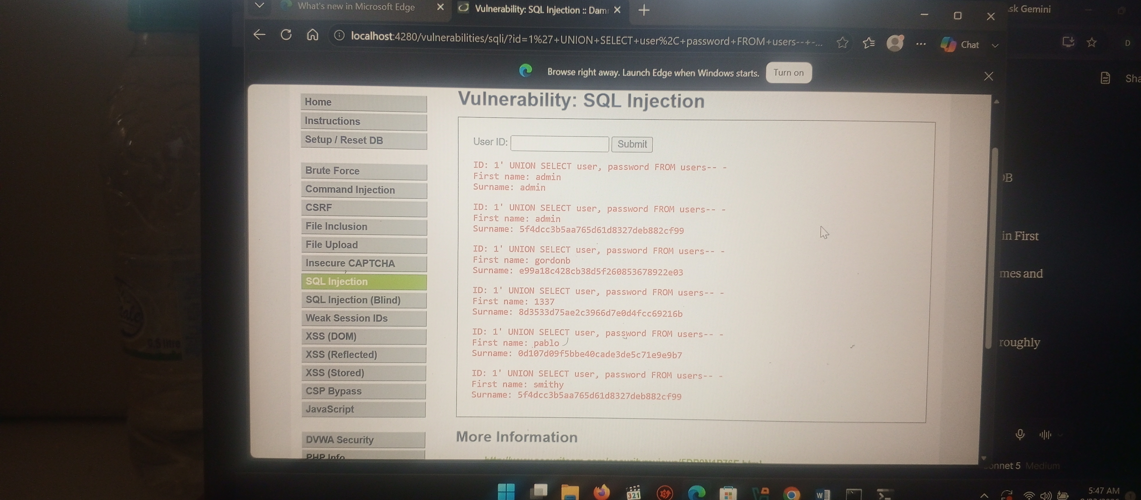

The retrieved hash values were not cracked or reversed as part of this exercise; they are reported only to confirm format and length.

9. Comparison of SQL Injection Techniques
Technique | How it works | Observable evidence
Error-based SQLi | Uses database error messages triggered by crafted input to reveal information. | Visible SQL/database error details.
Boolean-based Blind SQLi | Sends conditions that evaluate TRUE or FALSE and compares application responses. | Different messages or page behavior for true and false conditions.
Time-based Blind SQLi | Uses a conditional delay and infers results from response time. | A measurable delay when the tested condition is satisfied.

10. Security Impact
If a similar vulnerability existed in a real application, an attacker might be able to infer database names, tables, columns, and potentially sensitive records. Exposure of user credential data or password hashes could create further risk, especially where passwords are weak or hashing practices are outdated.
The findings in this report were obtained only in an intentionally vulnerable local DVWA laboratory. They should not be interpreted as evidence that an external production system is vulnerable.

11. Recommended Mitigations
- Use prepared statements and parameterized queries rather than building SQL statements from user input.
- Apply server-side input validation appropriate to the expected data type and format.
- Configure the database account with only the privileges required by the application.
- Prevent detailed database errors from being displayed to end users; log errors securely on the server.
- Store passwords using a modern, purpose-built password-hashing algorithm with unique salts and appropriate work factors.
- Perform regular, authorized security testing and remediate identified vulnerabilities.

12. Conclusion
The practical successfully identified and validated a Blind SQL Injection vulnerability in the controlled DVWA environment. Boolean TRUE/FALSE response differences and a time-based delay provided evidence that user input influenced database processing. Manual inference confirmed the “dvwa” database, the “users” table, and the “user” and “password” columns.
A password value length of 32 characters was observed via blind inference, and a follow-up UNION-based query on the related SQL Injection module confirmed retrieved values were 32-character hexadecimal strings consistent with MD5. No hash was cracked and no plaintext password is reported. The exercise highlighted the importance of parameterized queries, input validation, least-privilege database access, and secure password storage.
that were not performed.

